`

Integrating Mathematical Modeling with Machine Learning
to Identify Cancer Driver Genes

Seo-Yeon (Karen) Chung
Irvine, California

Table of Contents DELETE AND MAKE ABSTRACT THE 2ND PAGE
Abstract 1
Introduction 2
Hypothesis 3
Methods 4
I. Mathematical model of the cancer environment 4
II. Data retrieval and generation 5
III. Feature computation 6
Results 7
I. Comparison of feature value distributions across datasets 7
II. Ensemble method outperforms 8
II. Driver gene identification on in-vivo data 8
b. Statistical analysis and driver gene ranking 8
b. Cross-reference with CGC and NCBI 9
c. Biological insights: contexts of putative driver genes 10
Discussion 11
Conclusion 13
Appendix 13
I. Complete, ranked list of genes identified as driver genes by classifier and CGC. 13
II. Full colorectal cancer gene pathway scheme, retrieved from KEGG. 15
Works Cited 16

Abstract
The identification of cancer driver genes is a critical component of precision oncology. Given the large feature space of The Cancer Genome Atlas (TCGA), which catalogs millions of somatic mutations observed in human tumors, machine learning techniques are ideally suited to driver gene identification. In existing models, however, the objective assessment of such machine learners is complicated by unexplained errors in the mutational data used to train the algorithms and by the absence of a perfect drivers list. This study employs mathematical modeling in tandem with machine learning processes to construct an objective and accurate classifier that identifies cancer driver genes. In-silico dataset generation and machine learning training are coded in Go and Matlab, respectively; external datasets (TCGA, Cancer Genome Consensus, KEGG Database) are used for classifier evaluation. A set of in-silico mutational data is generated by the stochastic simulation of a differential equations model of feedback-controlled cancer population dynamics. The synthetic dataset, validated through the assessment of mutational pattern distributions, trains a selected machine learning algorithm, producing a driver gene classifier. The gene classifier prioritizes high-impact driver genes in four cancer types with >85% accuracy and is statistically significant at 1%. Additionally, the quality of the ranked list of putative driver genes is validated through enrichment analysis on a list of generally accepted driver genes and biological pathway analysis. Top colorectal cancer driver genes from the classifier hold key roles in the PI3K-AKT and Wnt pathways, which have well-documented implications in carcinogenesis. The interdisciplinary methodology developed here produces an efficient and unbiased cancer driver gene classifier that can be utilized to identify henceforth unknown driver genes, providing insight essential for targeted cancer screening and treatment.

Introduction
Cancer is caused by the accumulation of driver mutations in cells. Cells acquire about one mutation in every 30 million base pairs during cell division processes; while most of these are harmless passenger mutations, mutations that lead to the gain or loss of cellular function drive the formation of cancer and are therefore classified as driver mutations (Bailey et al.). Subsequently, driver genes are genes with the potential to harbor driver mutations. Driver genes represent a minority in the mutations that a malignant tumor harbors: while there are a median of 33 to 66 mutations in most solid tumors, between 5 to 8 of them are driver mutations responsible for tumor development (Vogelstein et al.). Driver genes are classified as either oncogenes that lead to activation of cellular function, or tumor suppressor genes that lead to loss of cancer prevention function (Pon and Marra). The identification of genes that drive tumorigenesis is an important first step in the development of targeted screenings and therapies. While driver genes can be distinguished through assessment of functional impact in biological experiments and clinical studies, the impracticality of performing functional testing in a high-throughput manner necessiates the development of bioinformatic methods that sorts candidate driver mutations (Pon and Marra). Recent advances in Next Generation Sequencing have helped identify millions of somatic mutations in tumors from thousands of cancer patients: The Cancer Gene Consensus (CGC) (Futreal et al.), a compilation of generally accepted cancer genes, contains around 500 driver genes, a small fraction out of approximately 20,000 human genes. This has encouraged the use of computational and machine learning approaches in driver gene classification. As compared to in-vivo, single-gene function validation (Source1, Source2, Source3), this computational approach is cost-efficient and capable of producing mass driver gene predictions. Statement about the two approaches needing to be used in conjunction (Source).
Several machine learning-based driver gene prioritization methods have been developed. These ratiometric methods identify frequency- or function-related mutation patterns observed in known driver genes but not in passenger genes. For example, MutSig and SomInaClust (Van den Eynden et al.) detect mutation frequency and clustering patterns, while OncodriveFM and OncodriveClust identify driver genes based on calculated functional impact bias OncodriveClust (Van den Eynden et al.). Methods such as 20/20+ (Tokheim et al.) and OncodriveROLE (Schroeder et al.) extend these paradigms, integrating multiple features of positive selection.
However, the accurate identification of cancer driver genes versus the more frequent but incidental passenger genes nevertheless remains a challenging task. Still a relatively nascent, the cancer-genomics-to-machine-learning paradigm has left unaddressed the common errors of machine learning. The Cancer Genome Atlas (TCGA) (Weinstein et al.), which is the mutation dataset used to train and test these above machine learning models, is large, complex, and prone to unknown sequencing errors. Furthermore, CGC is a generally accepted list of drivers but not a definite nor complete gold standard for driver genes. Regardless, the existing methods train and validate their machine learning algorithms using (1) the TCGA to generate the feature vector and (2) the CGC to label each gene as passenger, oncogene, or tumor-suppressor.
In this study, an alternative training set (“synthetic dataset” hereafter), independent from TCGA, is generated to train and ‘validate’ a machine learning model. Concretely, the high performance of the classifier serves as prior validation for the results that would be returned when the classifier is trained on the TCGA data. The training set is derived from a system of ordinary differential equations that models the system dynamics of in-silico cancer cells. The development of a synthetic dataset for use in training and validating the machine learning classifier has three major advantages. First, it allows avoidance of developing a classifier using training datasets with unknown errors. Second, training with an external dataset prevents classifier overfitting to any portion of TCGA. Most importantly, the synthetic training data provides a clear evaluation standard; with the synthetic ‘driver genes’ already known, we have a solid ground truth label to compare the classifier’s predictions on. The features of the machine learning classifier integrated multiple features related to mutational frequency, clustering, and projected functional impact. Once these information were extracted from the synthetic dataset and the classifier learned to distinguish drivers in the synthetic dataset, we used it to classify driver genes documented in TCGA. Our model was able to prioritize highly relevant known driver genes across the four cancer types.

Goals
1. Establishing a mathematical modeling-simulating pipeline to generate synthetic MAF data, [benefit.]
2. Using synthetic data to construct a high-accuracy classifier that outperforms existing methods in driver gene retrieval.
3. Extracting new biological insights by analyzing the set of genes associated with discriminating CpG features from the diagnostic classifiers.

All three of the aforementioned aims were met in this study.

Methods

I. Mathematical model of the cancer environment
The study’s first goal is to characterize the cancer environment, in which tumors evolve by acquiring a series of driver genes over time. In the mathematical model, we consider three homogenous populations of cells: normal cells, N(t), and driver-mutated cancer cells, M(t).
$$\frac{dN}{dt}=v_{N}N(t)L(t)\left(\left(p_{n}-p_{s}\right)-d_{N}\right)-D\left(t\right)N(t)$$
$$\frac{dM}{dt}=\left(v_{M}-d_{M}\right)M(t)L(t)+v_{N}N(t)\left(2p_{s}+p_{a}\right)L(t)-D\left(t\right)M(t)-s(t)I(t)M(t)$$
We denote $μ$, the probability of mutation at every normal cell division, where $μ=μ_{t}+μ_{o}$, the sum of probabilities of a normal cell’s gene mutating into a tumor suppressor gene $μ_{t}$ and into an oncogene $μ_{o}$. Therefore, we denote as the following the probability of one normal cell dividing into two normal cells ${(p}_{n}$), asymmetrically into one normal and one cancer cell ${(p}_{a}$), and two cancer cells ${(p}_{s}$), as the following 1[15]:
$p_{n}={\left(1-μ\right)}^{2}$ $p_{a}=2μ\left(1-μ\right)$ $p_{s}=μ^{2}$
The normal and cancerous cells are assumed to grow according to a logistic growth function, L(t). The logistic function formulates cellular growth rates and oxygen concentrations as interdependent with each other. Specifically, the maximum size of the combined normal and cancerous cells is defined by the maximum level of oxygen sustainable in the system ($O_{2_{max}}$); the minimum level of oxygen is ($O_{2_{thresh}}$). A low level of oxygen is linked to higher rates of necrosis, D(t).
$L\left(t\right)=1-\frac{O_{2_{max}}-O_{2}(t)}{O_{2_{thresh}}}$ ${ O}_{2}\left(t\right)=\frac{v_{o}}{a_{o}+\left(M\left(t\right)+N\left(t\right)\right)\left(c_{1}-\frac{c_{1}-c_{2}}{1+{\left(\frac{5000}{N\left(t\right)}\right)}^{10}}\right)}$ $D\left(t\right)=\frac{D_{max}}{1+{\left(\frac{O_{2}(t)}{O_{2_{max}}-O_{2_{thresh}}}\right)}^{5}}$
Cancer cells’ growth rate ($v_{M}$) is regulated with a positive feedback loop from the concentration of cancer cells affected by oncogenic mutations. $α_{v}$ is a feedback strength parameter.
Similarly, cancer cells’ apoptosis rate ($d_{M}$) is regulated with a negative feedback loop from the concentration of cancer cells affected by tumor suppressing mutations. $α_{d}$ is a feedback strength parameter.
$v_{M}=v_{M0}+\left(\frac{α_{v}}{1+\left(\frac{μ_{o}}{μ}\right)/M\left(t\right)}\right){ d}_{M}=d_{M0} - d_{M}\left(\frac{α_{d}}{1+\left(\frac{μ_{t}}{μ}\right)/M\left(t\right)}\right)$

II. Data retrieval and generation
We retrieved somatic single nucleotide variation (SNV) data from the TCGA projects, which represents data sampled from mutated tissues from 11,000 patients of thirty-four cancer types. In our analysis, we only considered the three broadest mutation types: missense, nonsense, and silent.
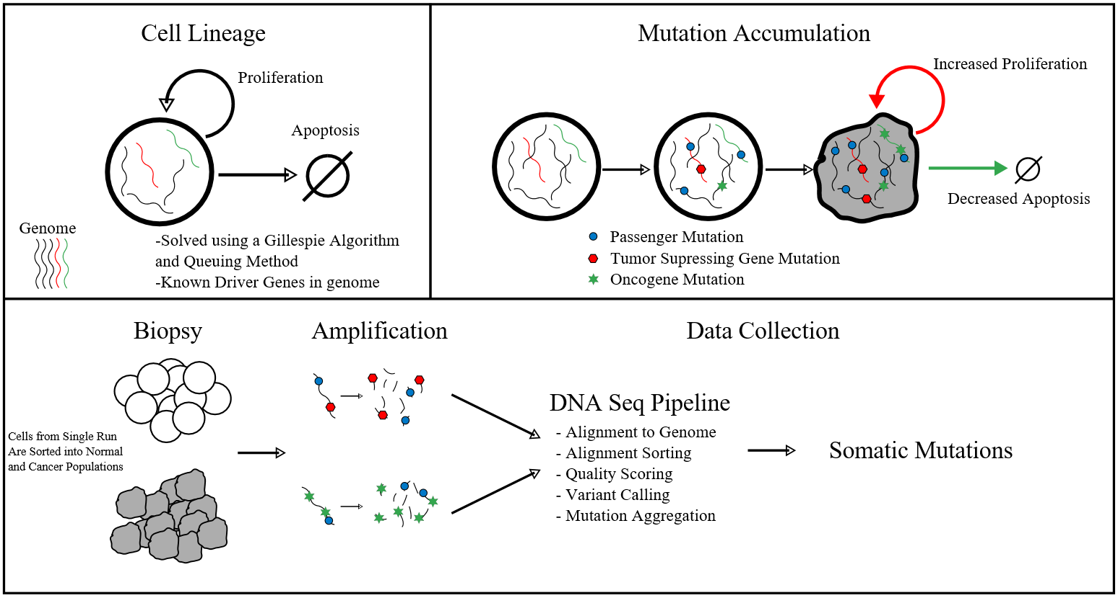
Figure 1a. Workflow: generation of the in-silico, synthetic data set

We next generated our own dataset⸺referred to as the “synthetic dataset” hereafter⸺ that closely follows the format of the TCGA dataset. The steps are as illustrated in Figure 1. 500,000 cells are instantiated in silico, where each harbors 10,000 genes with unique nucleotide sequences with an average length of 100 base pairs. Then, the Gillespie Algorithm was employed to model the population’s individual cells’ evolution over time. The algorithm dictated the fates of individual cells across discrete time frames spanning seventy-five simulated years; at each step, a cell either divided or underwent apoptosis. A dividing cell furthermore had a specific probability of acquiring a mutation. The number of cancerous mutation(s) that the cell accumulates altered its probability of dividing or undergoing apoptosis at the next time step. Naturally, the laws of cellular division, apoptosis, and corresponding oxygen usage were dictated by the mathematical model of the cancer environment as detailed on the above section. In other words, the Gillespie Algorithm bridged the gap between the continuous population dynamics model and the set of discrete data on individual cells’ mutational profiles. A priority queue method was implemented in the Go programming language, which was used exclusively for this synthetic data generation process.
New Paragraph Lorem ipsum dolor sit amet, consectetur adipiscing elit, sed do eiusmod tempor incididunt ut labore et dolore magna aliqua. Ut enim ad minim veniam, quis nostrud exercitation ullamco laboris nisi ut aliquip ex ea commodo consequat. Duis aute irure dolor in reprehenderit in voluptate velit esse cillum dolore eu fugiat nulla pariatur. Excepteur sint occaecat cupidatat non proident, sunt in culpa qui officia deserunt mollit anim id est laborum

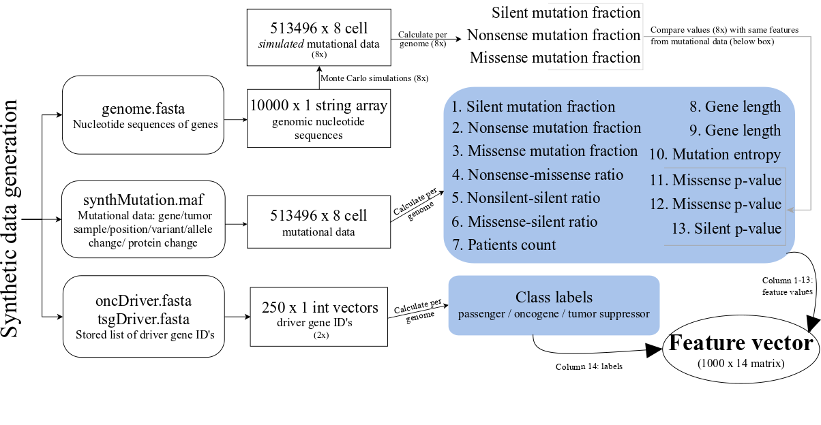
Figure 1b. Processing of the synthetic data into a feature vector, the input to machine learning algorithms.
The synthetic data produced as a result of the in-silico generation are in FASTA and MAF formats, which are standard formats for storing genomic and mutational data. However, these formats needed to be converted into data structures that allow easy indexing for calculations. Thus, the raw data files were converted into cells, arrays, and vectors, giving way to the calculation of feature values on a per-gene basis.

III. Feature computation
We initially created thirteen features that we hypothesized can characterize and discriminate between passenger and driver cancer genes in both our synthetic dataset and the TCGA dataset.
The features can be divided into five categories: (1) the frequency of a mutation type (silent, missense, and nonsense) in all documented mutations of the gene, (2) the ratio between mutation types (nonsense to missense, missense to silent, silent to nonsilent), (3) the clustering, or recurrence of mutations at hotspots (missense, or all types), and (4) the significance of certain types of mutations (missense, nonsense, or silent) at their locations. The remaining two features are the number of samples the gene is found mutated and gene length, respectively.
Mutational clustering was measured by the normalized Shannon’s entropy value of ${{\text{Σ}}_{\text{i}}p_{i}log_{2}p_{i}}/{log_{2}k}$ , where $k$= # of missense or all types of mutations, and $p_{i}$ = # of missense or any mutations in the gene’s $i$th codon. Driver genes were expected to have higher occurrences of hotspots, thus lower entropy values, than passenger genes. The significance of each type of mutation in the gene was measured by computing their p-values, where we created artificial permutations of the synthetic dataset with Monte Carlo simulations. Specifically, for each gene, we shuffled each mutation to a different spot in the gene with the same nucleotide as in the observed spot (the total mutation count remained fixed). After eight simulations, the (missense, nonsense, silent) p-value was calculated as the fraction of simulated datasets with (missense, nonsense, silent) mutation counts greater than or equal to that of the original dataset. Again, driver genes were expected to be more statistically significant and therefore assume lower p-values on average.

Results

I. Comparison of feature value distributions across datasets
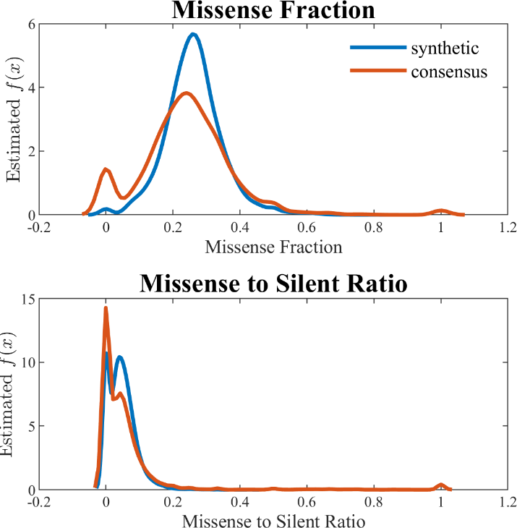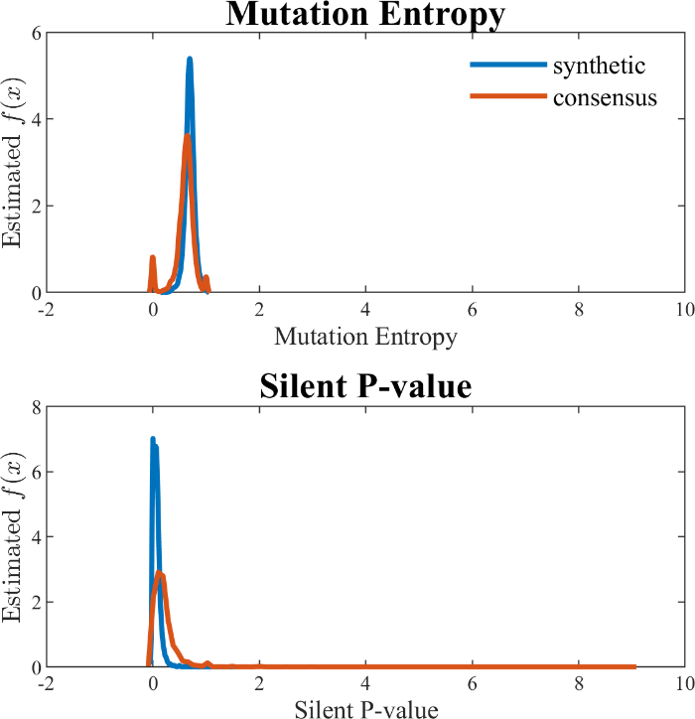
Figure 2. Comparison of feature value distributions across datasets. Each plot illustrates one gene feature category. (A): mutations type; (B): mutations type ratios; (C): mutations clustering; (D) mutation significance.

We compared the distribution of the features’ values across the two datasets in order to predict the features’ usefulness and to verify the similarity of our mathematical model-derived synthetic dataset to the TCGA dataset. For all four categories, we found that genes in our synthetic dataset have similar characteristics to those in the TCGA dataset (Fig. 2), and aforementioned predictions on driver genes’ entropy and p-value distributions were validated. For features for which one or more gene types assume different distributions across datasets, we evaluated the biological feasibility of the synthetic dataset’s distribution; for example, the higher frequency of low mutation in TSGs in our synthetic data (Fig. 2C) may indicate an overrepresentation of tumor suppressor genes with hotspot mutations, analogous to the TP53 gene.

II. Ensemble method outperforms
We proceeded to create a machine learning model with our synthetic data as the training and validating data. Because the synthetic data does not contain unexplained errors like the TCGA data, it is more reliable for creating a robust machine learning model. The random forest algorithm was used, and to account for the imbalance between the passenger and driver class, we applied the RUSBoost algorithm, which reduces bias towards the majority class through a iterative sampling method that prioritizes the correction of a previously misclassified item (Seiffert et al.). Results of 15% hold-out validation on the classifier is reported in Table 1. The classifier’s accuracy well exceeds 90% and its Cohen’s kappa, a measure of accuracy that is adjusted for chance selection, exceeds 0.8.
 | LR | DT | pSVM | RF | RUS
Recall
p-value
Table 1. Cross-validation performance of RUSBoosted random forest classification on driver gene classification in synthetic dataset.
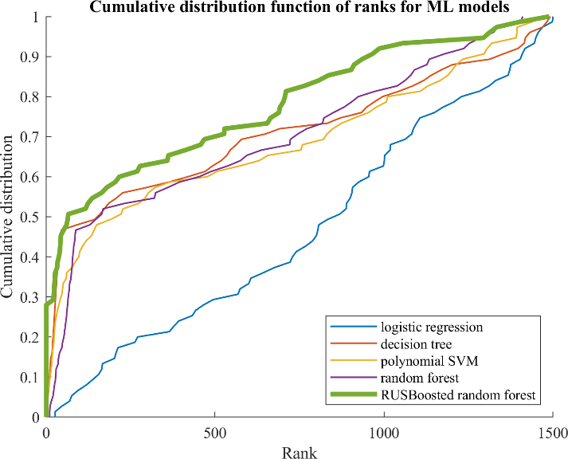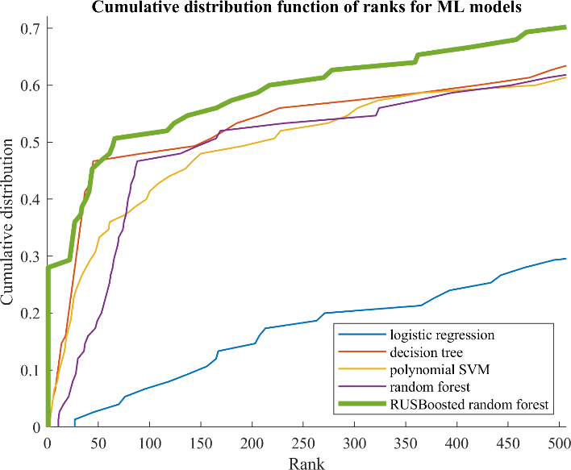

II. Driver gene identification on in-vivo data
a. Data partitioning

b. Statistical analysis and driver gene ranking
Cancer Name | Accuracy | Drivers identified | P-value
Colorectal | 85.8%
Pancreatic | 85.6%
Breast | 86.9%
Melanoma | 87.2%

Having validated our driver gene classifier with the synthetic dataset, we applied it to four cancer types in the TCGA dataset: colorectal cancer, pancreatic cancer, breast cancer, and melanoma. This approach identified 118, 531,1673, and 1660 driver genes in each respective cancer type, including most well-known mutations (e.g. oncogenes like BRAF, tumor suppressors like TP53).

b. Cross-reference with CGC and NCBI
We found that our classifier identifies key driver genes included in the cancer census gene (CGC) list, which was downloaded from COSMIC as a reference list for generally accepted cancer genes. The number of oncogenes, tumor suppressor genes, and driver genes (without regards to type) that are reported as driver genes by both CGC and our classifier are reported in Table 2.
To initialize our analysis of the top genes predicted by our classifier, we ranked the putative driver genes according to their driver scores. Driver scores were calculated as the combined probability of the gene being either a driver oncogene or tumor suppressor gene; this is the equivalent of the fraction of observations of the OG and TSG classes in the nodes of the random forest ensemble. After the putative drivers were ranked, a clear CGC gene enrichment was found for the top ranked genes for the four types analyzed (Table 2). On average, 62.5%, 29.1% and 23.0% of the top 10, 30 and 50 selected genes were CGC documented driver genes. The first column of Table 3 reports the names of the top fifteen putative driver genes that are also reported CGC driver genes; the second column reports the number of publication hits in NCBI which are found to be relevant to a query cancer type plus a query gene. The top CGC-validated putative genes are apparently more likely genes that have well-documented relevance to the cancer type.
 | # OG overlap | # TSG overlap | # drivers overlap | Recall: top 10 | Recall: top 30 | Recall: top 50
Colorectal | 26 | 12 | 66 | 70.0% | 33.3% | 24.0%
Pancreatic | 17 | 12 | 51 | 50.0% | 20.0% | 18.0%
Breast | 32 | 12 | 75 | 70.0% | 33.3% | 26.0%
Melanoma | 35 | 13 | 80 | 60.0% | 30.0% | 24.0%
Table 2. Performance of synthetic data-validated random forest classifier on driver gene classification in individual datasets of TCGA cancers.
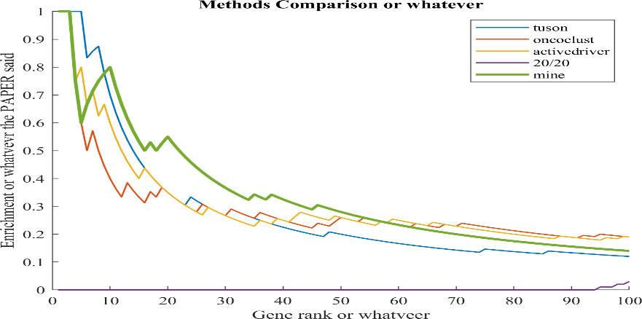
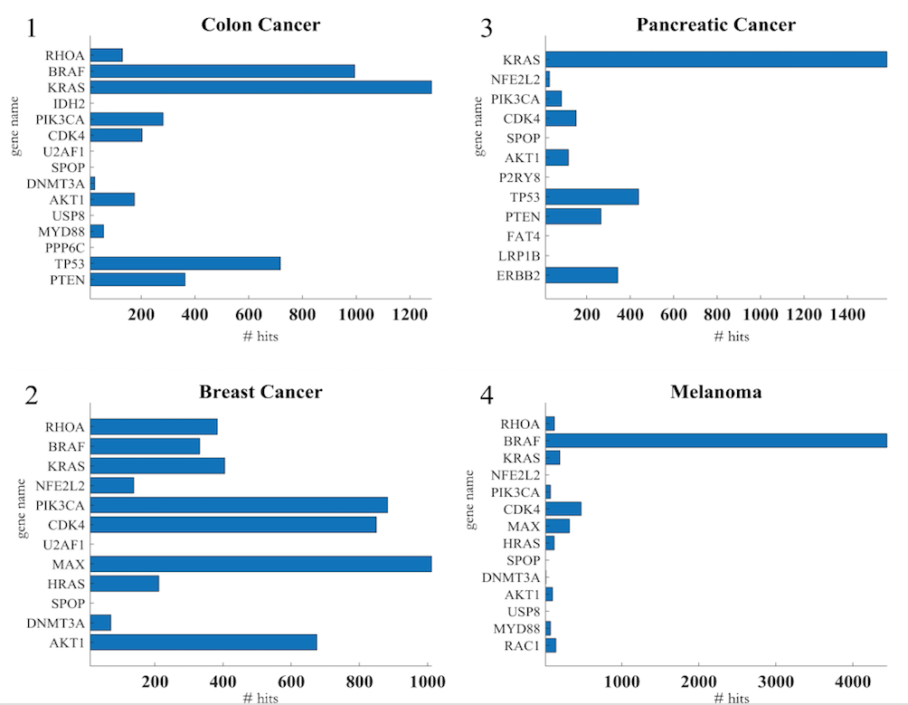

Table 3. The names and NCBI publication hits of the top fifteen ranked putative genes

c. Biological insights: contexts of putative driver genes
We additionally validated that the identified driver genes are active in biological pathways through a pathway analysis with the Kyoto Encyclopedia of Genes and Genomes (KEGG) (Ogata et al.); the identified putative driver genes across the four cancer types were shown to be active in pathways involved in cell development and apoptosis, including PI3K-AKT and Wnt/β-Catenin. (The full pathway is included in the Appendix.)
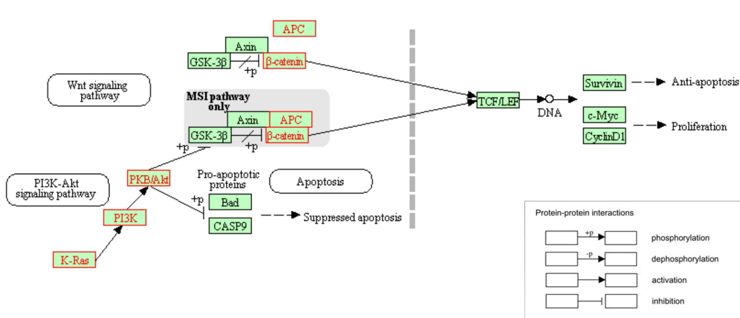Figure 3. Interaction pathway of select colorectal cancer driver genes identified by our classifier. The proteins typed in red are affiliated with genes identified by our classifier as a driver.

Phosphatidyl-inositol 3-kinase (PI3K) activity is associated with the transformation of viral oncoproteins; PI3K (encoded by PIK3CA, etc.) is central in several cellular processes, such as proliferation, growth, apoptosis, and cytoskeletal rearrangement. The primary consequence of PI3K activation is the generation of the second messenger PIP₃, which activates downstream pathways that involve proteins involving AKT and others. The phosphatase PTEN terminates the PI3K-AKT signaling pathway by dephosphorylating PIP₃ to PIP₂. Mutations on genes in the pathway --- PIK3CA, AKT1, and PTEN --- lead to aberrant pathway activation, and often, carcinogenesis. Our method is able to prioritize this signaling motif: lists of top ten driver genes for each of the four cancer types include at least two of these three PI3K pathway genes.
Another signaling pathway implicated in the driver genes returned by our method is the Wnt pathway. Signaling by the Wnt proteins via the transcription co-activator β-catenin controls embryonic development and adult homeostasis. β-catenin (encoded by CTNNB1) is regulated and destroyed by the beta-catenin destruction complex, and in particular by the adenomatous polyposis coli (APC) protein, encoded by the tumor-suppressing APC gene. The loss of negative Wnt signaling regulation by APC is responsible for around 15% of colorectal cancer cases.
We were able to construct a signaling pathway of colorectal cancer carcinogenesis based upon the list of predicted genes active in either the Wnt or PI3K pathway. Figure 3 is retrieved from KEGG as is a partial summary of the pathway. Products of the KRAS (driver score rank #3), PIK3CA (rank #5), AKT1 (rank #10), APC (rank #25), and CTNNB1 (rank #43) genes are depicted (Appendix).

Discussion
In this study, we have introduced a novel cancer driver gene identification method that is, fundamentally, founded on the mathematical dynamics of the cancer system. Instead of splitting the TCGA dataset into training, validation, and test sets, we synthesized with the mathematical model a new dataset of in-silico cancer mutational profiles. This synthetic dataset was used to train and validate a machine learning classifier. The random forest classifier extracted information on genes’ mutation patterns, some of which are more computationally expensive to calculate (e.g. the p-values) than others (e.g. the fractions of certain mutation types). After training on our synthetic data, it learned to prioritize driver genes based on their mutational pattern statistics. The high performance of the classifier serves as prior validation for the results that would be returned when the classifier is trained on the TCGA data. The benefits of synthetic data are threefold: avoiding training with erroneous data, avoiding overfitting to that data, and gaining an objective evaluation criteria from predetermined driver-versus-passenger labels.
We used the trained classifier to find driver genes in four cancer types included in the TCGA dataset: colorectal, pancreatic, breast, and melanoma. This approach produced a list of >100 driver genes in the four cancers, with most well-known oncogenic mutations (e.g. BRAF, PIK3A, AKT1) and tumor-suppressing mutations (e.g. TP53, PTEN) enriched in the top 15 list according to driver scores. Furthermore, Genes prioritized most highly across four cancer types were implicated in major signaling pathways often responsible for carcinogenesis. This is highlighted in our analysis of the list of colorectal cancer genes returned by our classifier, which included key genes of the PI3K-AKT pathway and the Wnt signaling pathway that fit into a coherent gene interaction pathway of colorectal cancer carcinogenesis.
There are areas for improvement in our method, the most important of which is improving the model’s ability to differentiate between an oncogene and tumor suppressor gene once a gene is identified as a driver. This would likely be achieved by refining the in-silico generation of the synthetic data to produce a batch of simulated mutations that more closely resemble the nuances of oncogenes and tumor suppressors documented in TCGA.

Conclusion
By integrating a mathematical analysis of cancer systems biology with a statistical analysis of genomic mutations, we created a method that was shown to be able to detect candidate cancer driver genes. The method, validated through cross-referencing of known driver genes and pathways, can be used to classify potential driver genes as passenger or driver genes.

Appendix

I. Complete, ranked list of genes identified as driver genes by classifier and CGC.
# | Colorectal | Pancreatic | Breast | Melanoma
1  2  3  4  5  6  7  8  9  10  11  12  13  14  15  16  17  18  19  20  21  22  23  24  25  26  27  28  29  30  31  32  33  34  35  36  37  38  39  40  41  42  43  44  45  46  47  48  49  50  51  52  53  54  55  56  57  58  59  60  61  62  63  64  65  66  67  68  69  70  71  72  73  74  75  76  77  78  79 | RHOA  BRAF  KRAS  IDH2  PIK3CA  CDK4  U2AF1  SPOP  DNMT3A  AKT1  USP8  MYD88  PPP6C  TP53  PTEN  FAT4  MAP2K1  LRP1B  ERBB2  B2M  PTPRT  EP300  NCOR1  ARID2  APC  ARID1A  CUX1  PPP2R1A  FAT1  KMT2C  KMT2D  IDH1  EBF1  EGFR  PTCH1  MAPK1  CD79B  NR4A3  FGFR2  NRAS  AR  FOXA1  CTNNB1  KDM6A  POLE  ATRX  PTPRC  GNA11  RAF1  TLX3  CDH1  RB1  SETD2  SETBP1  IL7R  WHSC1  BRCA2  PAX3  KEAP1  BCORL1  PDGFRB  TFEB  ATR  SLC34A2  ACVR1 | KRAS  NFE2L2  PIK3CA  CDK4  SPOP  AKT1  P2RY8  TP53  PTEN  FAT4  LRP1B  ERBB2  PTPRT  EP300  NCOR1  ARID2  APC  ARID1A  CUX1  FAT1  KMT2C  KMT2D  IDH1  EBF1  PTCH1  MAPK1  XPO1  FGFR2  AR  FOXA1  MYCN  CTNNB1  KDM6A  POLE  ATRX  PTPRC  RAF1  JUN  RB1  SETD2  SETBP1  IL7R  WHSC1  BRCA2  PAX3  KEAP1  DDX3X  CCNB1IP1  ATR  SLC34A2 | RHOA  BRAF  KRAS  NFE2L2  PIK3CA  CDK4  U2AF1  MAX  HRAS  SPOP  DNMT3A  AKT1  USP8  MYD88  P2RY8  TP53  PTEN  NPM1  FAT4  MAP2K1  LRP1B  ERBB2  B2M  PTPRT  HIST1H3B  EP300  NCOR1  ARID2  APC  ARID1A  CUX1  PPP2R1A  FAT1  KMT2C  KMT2D  IDH1  EBF1  EGFR  PTCH1  MAPK1  CD79B  NR4A3  XPO1  FGFR2  CDK6  NRAS  AR  FOXA1  MYCN  CTNNB1  KDM6A  POLE  ATRX  PTPRC  RAF1  JUN  CDH1  RB1  SETD2  SETBP1  IL7R  WHSC1  BRCA2  PAX3  KEAP1  BCORL1  PDGFRB  DDX3X  CCNB1IP1  TFEB  ATR  TAL1  SLC34A2  ACVR1 | RHOA  BRAF  KRAS  NFE2L2  PIK3CA  CDK4  MAX  HRAS  SPOP  DNMT3A  AKT1  USP8  MYD88  RAC1  P2RY8  PPP6C  TP53  PTEN  NPM1  FAT4  MAP2K1  LRP1B  ERBB2  B2M  PTPRT  HIST1H3B  EP300  NCOR1  ARID2  APC  ARID1A  CUX1  PPP2R1A  FAT1  KMT2C  KMT2D  IDH1  EBF1  EGFR  PTCH1  MAPK1  CD79B  VHL  NR4A3  XPO1  FGFR2  CDK6  NRAS  AR  FOXA1  MYCN  CTNNB1  KDM6A  NKX2-1  POLE  ATRX  PTPRC  GNA11  RAF1  TLX3  JUN  CDH1  RB1  SETD2  SETBP1  IL7R  WHSC1  BRCA2  PAX3  KEAP1  BCORL1  PDGFRB  DDX3X  CCNB1IP1  TFEB  ATR  TAL1  SLC34A2  ACVR1

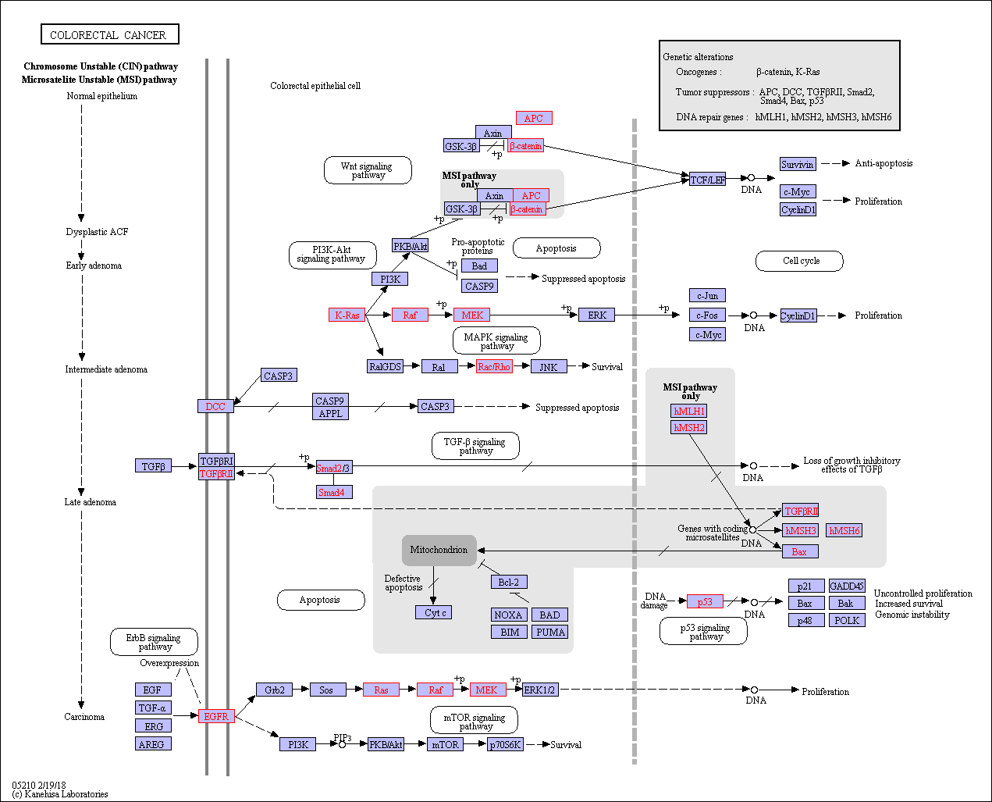
II. Full colorectal cancer gene pathway scheme, retrieved from KEGG.

Works Cited
Bailey, Matthew H., et al. “Comprehensive Characterization of Cancer Driver Genes and Mutations.” Cell, vol. 173, no. 2, 2018, p. 371–385.e18, doi:10.1016/j.cell.2018.02.060.
Futreal, P. Andrew, et al. A CENSUS OF HUMAN CANCER GENES. Vol. 4, no. 3, 2009, pp. 177–83, doi:10.1038/nrc1299.A.
Ogata, Hiroyuki, et al. “KEGG: Kyoto Encyclopedia of Genes and Genomes.” Nucleic Acids Research, vol. 27, no. 1, 1999, pp. 29–34, doi:10.1093/nar/27.1.29.
Pon, Julia R., and Marco A. Marra. “Driver and Passenger Mutations in Cancer.” Annual Review of Pathology: Mechanisms of Disease, vol. 10, no. 1, 2015, pp. 25–50, doi:10.1146/annurev-pathol-012414-040312.
Schroeder, Michael P., et al. “OncodriveROLE Classifies Cancer Driver Genes in Loss of Function and Activating Mode of Action.” Bioinformatics, vol. 30, no. 17, 2014, pp. 549–55, doi:10.1093/bioinformatics/btu467.
Seiffert, Chris, et al. RUSBoost : A Hybrid Approach to Alleviating Class Imbalance. Vol. 40, no. 1, 2010, pp. 185–97.
Tokheim, Collin J., et al. “Evaluating the Evaluation of Cancer Driver Genes.” Proceedings of the National Academy of Sciences, vol. 113, no. 50, 2016, pp. 14330–35, doi:10.1073/pnas.1616440113.
Van den Eynden, Jimmy, et al. “SomInaClust: Detection of Cancer Genes Based on Somatic Mutation Patterns of Inactivation and Clustering.” BMC Bioinformatics, vol. 16, no. 1, ???, 2015, pp. 1–12, doi:10.1186/s12859-015-0555-7.
Vogelstein, B., et al. “Cancer Genome Landscapes.” Science, no. March, 2013, http://www.sciencemag.org/content/339/6127/1546.short.
Weinstein, John N., et al. “The Cancer Genome Atlas Pan-Cancer Analysis Project.” Nat Genet. 2013 October ; 45(10), vol. 45, no. 10, 2014, pp. 1113–20, doi:10.1038/ng.2764.
Zhan, T., et al. “Wnt Signaling in Cancer.” Nature Publishing Group, vol. 36, no. 11, Nature Publishing Group, 2016, pp. 1461–73, doi:10.1038/onc.2016.304.

